|  |  |  |  |  |  |
| --- | --- | --- | --- | --- | --- |
| Date | 13-Dec-22 | | | Tester Name | Richard Belanger |
| Environment | Penfax - Test | | | Login used | TEST2 |
| Operating System | Select OS | Version: | Update: | | |
| Software Used | Select Software | Version: | Update: | | |
| Select Software | Version: | Update: | | |
| Release version | 22.4.1 | | | | |
| Title | M27 Reversal and Adjustment through OLC and DCT | | | | |
| Test Type | Regression | | | | |
| Test Scenario | M27.03 Reverse a Contribution Posting | | | | |
|  |  | | | | |
| Expected Results | Contribution History should show the adjustment posting records.  Payroll History should show the difference of posted contribution and its details.  Accounting should be verified in General Ledger. | | | | |
| Pass/Fail | Pass | | | JIRA# | N/A |

Describe your steps with screenshots:

1. Bring up an active MEPP member and note down the existing normal posting.

Payroll History

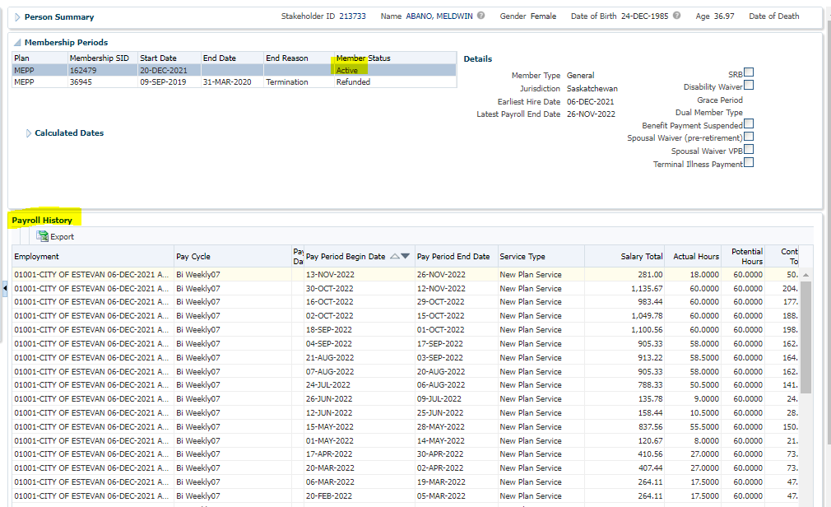

Contribution History

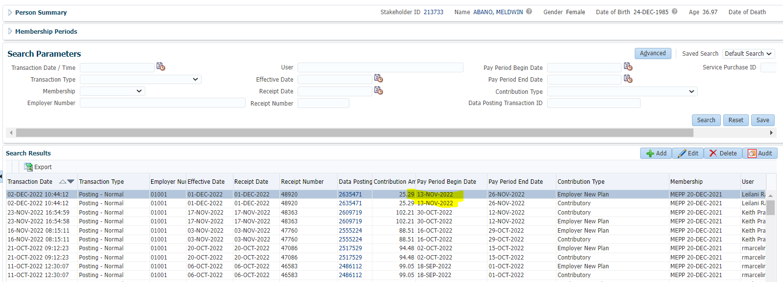

1. Log into MEPP DCT and select the Employer from the dropdown> Click on Create New File.

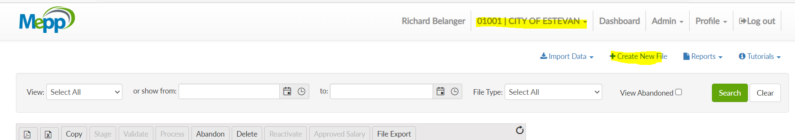

1. Select Contribution from the dropdown.

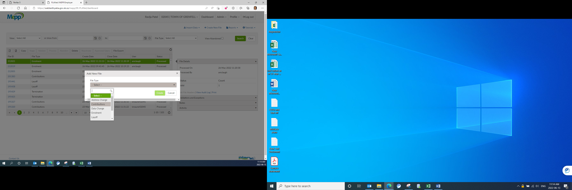

1. Input Pay Cycle and Pay Period and click on Create. Pay Period should be the same as the existing normal posting.

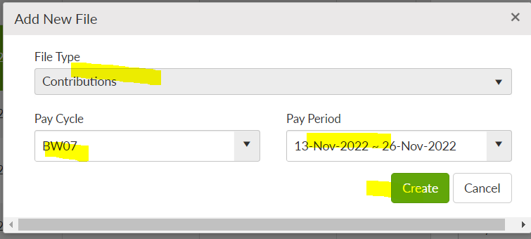

1. Click on File ID.

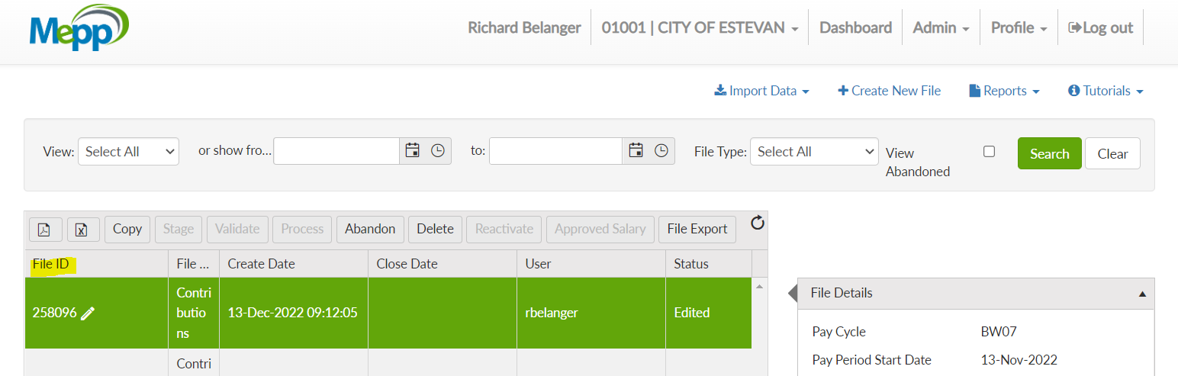

1. Click on Add to add the transactions.

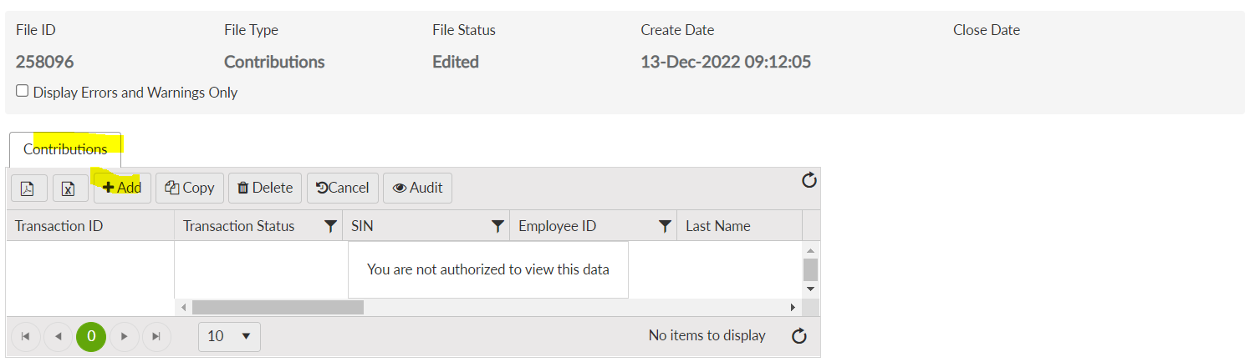

1. Input all the required details and Save. Contribution amount should be the same but in negatives, contribution type should be selected as Adjustment and all other details should be the same as the existing normal posting.

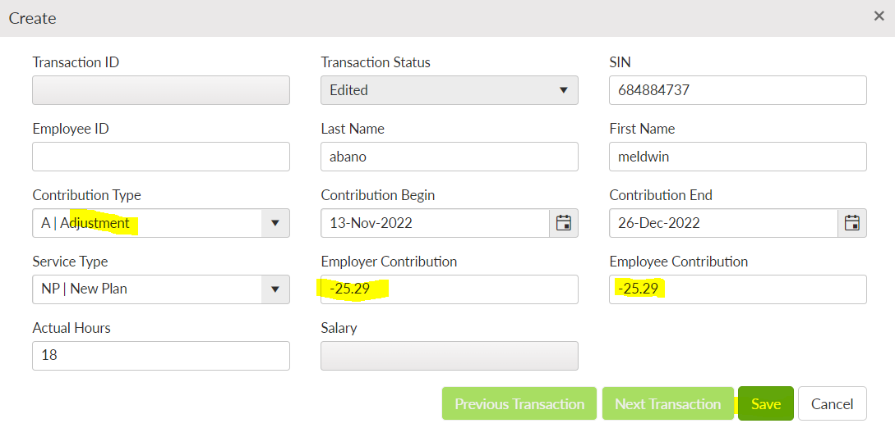

1. Under File Details, click on Validate -> Approve Salary -> Process to process the contribution file>Processed

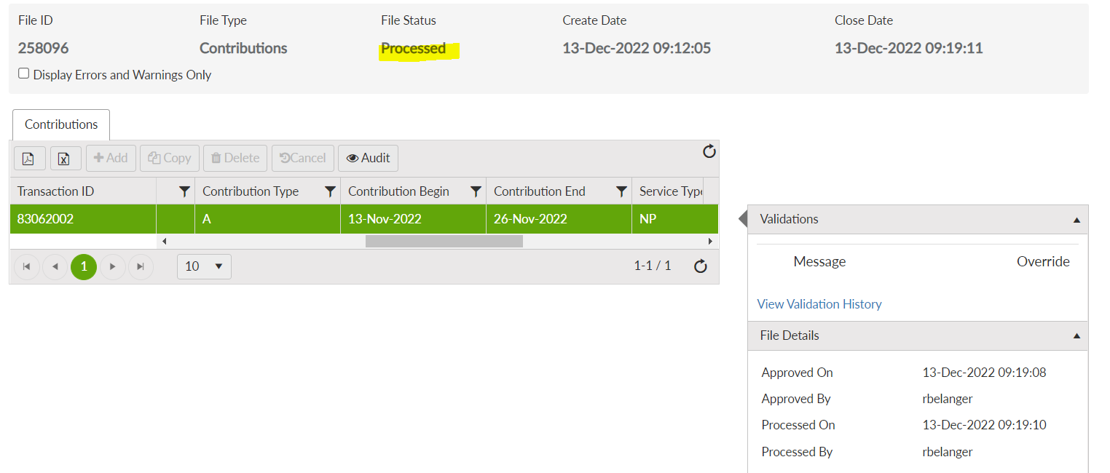

1. Log into Penfax. Click on Batches -> Data Posting Batches. Search with the employer and then click on the batch id you just processed in DCT.

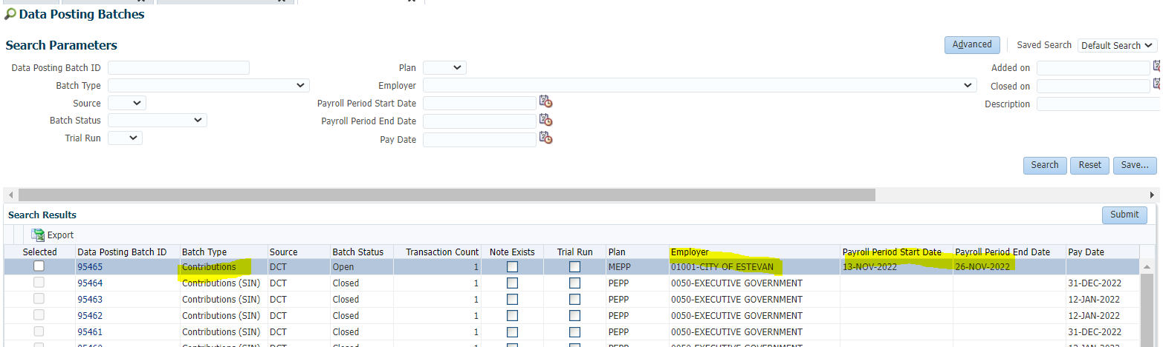

1. Go to Pending Tab. Verify the details in header. Ignore the warning. 2 validation errors are for remittance.

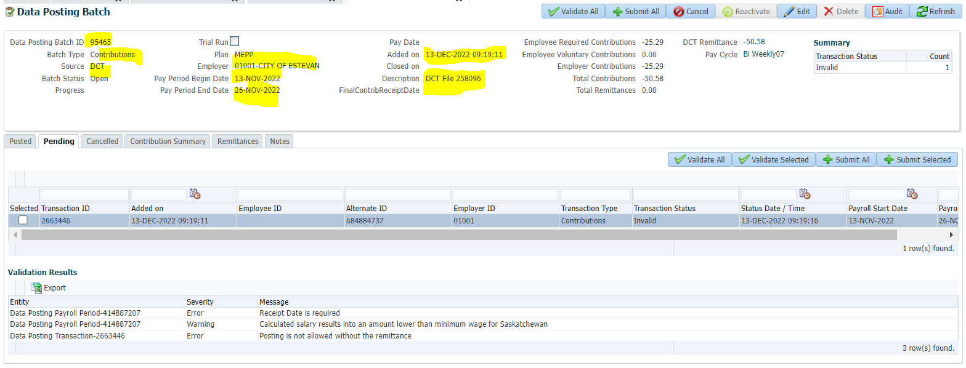

1. Go to Remittance tab and link the same remittance ID as that was in the original data posting batch for an existing normal posting.

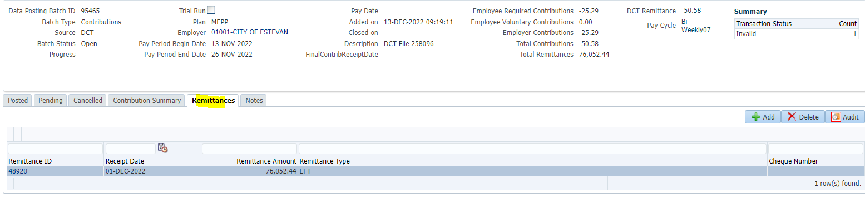

1. Go to Pending tab and click on Validate All and then Submit All.

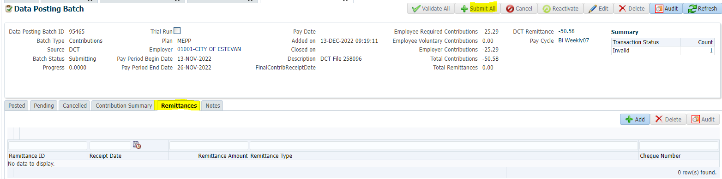

1. Go to Posted tab and you can see the batch status is closed now so that contribution should be posted to member’s account.

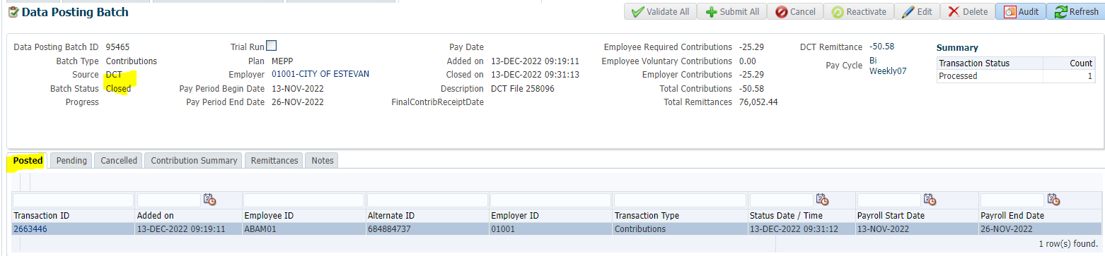

1. Bring up member again and go to Contribution History.

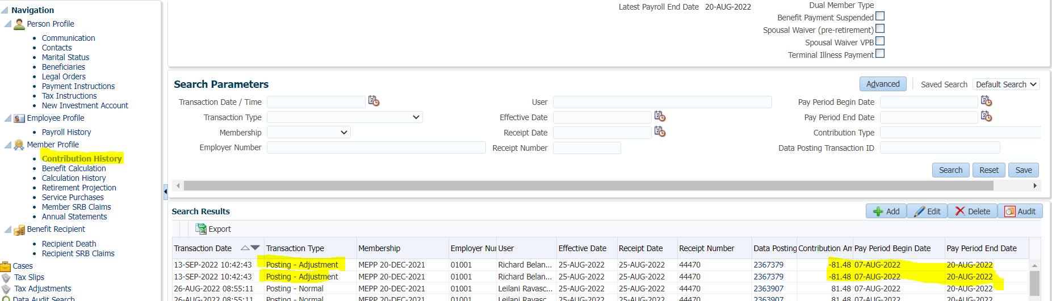

1. Go to Payroll History.

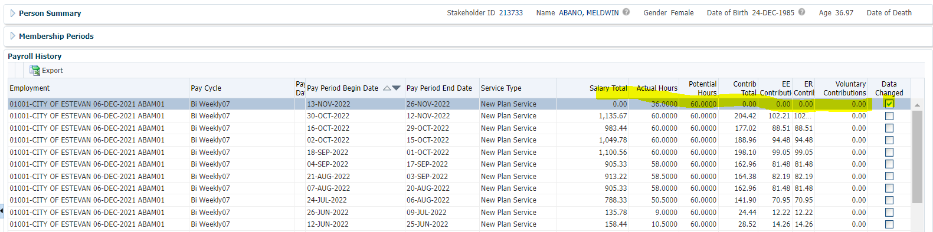

1. Go to Data Posting Batch -> Contribution Summary and click on Journal Number.

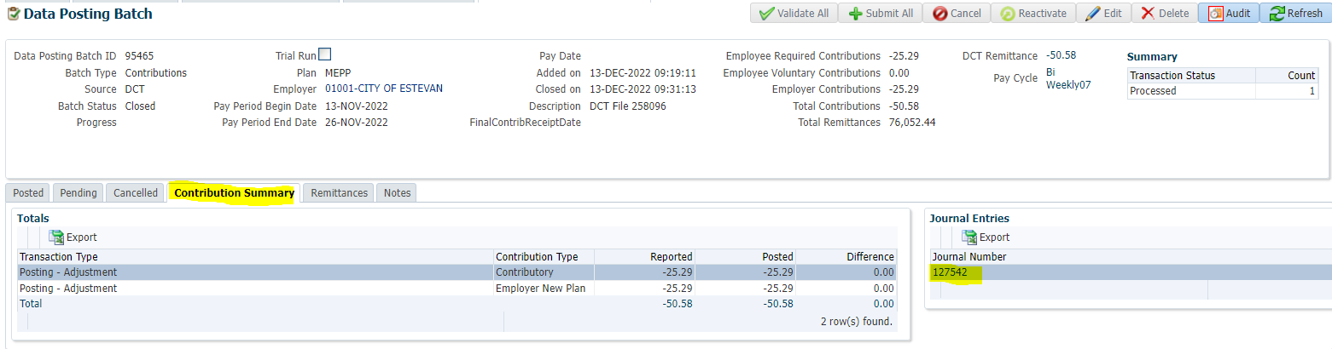

1. Verify the Journal entry.

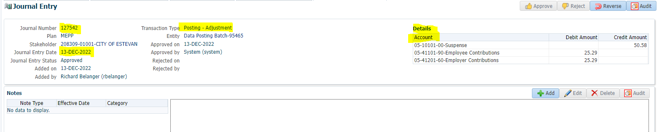

1. Go to Accounting -> General Ledger -> General Ledger. Search with Plan and Journal Number. Verify the accounting.

